**Exercise 1: Implementing the Singleton Pattern**

**Code:**

import java.util.Scanner;

public class Logger {

    private static Logger instance;

    private Logger() {

        System.out.println("Logger instance created.");

    }

    public static Logger getInstance() {

        if (instance == null) {

            instance = new Logger();

        }

        return instance;

    }

    public void log(String message) {

        System.out.println("[LOG] " + message);

    }

}

public class Main {

    public static void main(String[] args) {

        Scanner scanner = new Scanner(System.in);

        Logger logger1 = Logger.getInstance();

        System.out.println("Enter log messages (type 'exit' to quit):");

        while (true) {

            System.out.print(">> ");

            String input = scanner.nextLine();

            if (input.equalsIgnoreCase("exit")) {

                break;

            }

            logger1.log(input);

        }

        Logger logger2 = Logger.getInstance();

        if (logger1 == logger2) {

            System.out.println("✅ logger1 and logger2 are the same instance.");

        } else {

            System.out.println("❌ logger1 and logger2 are different instances.");

        }

        scanner.close();

    }

}

**Output:**

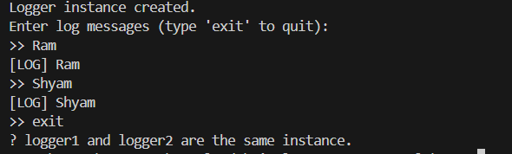

**Exercise 2: Implementing the Factory Method Pattern**

**Code:**

import java.util.Scanner;

public interface Document {

    void open();

}

public abstract class DocumentFactory {

    public abstract Document createDocument();

}

public class WordDocumentFactory extends DocumentFactory {

    public Document createDocument() {

        return new WordDocument();

    }

}

public class PdfDocumentFactory extends DocumentFactory {

    public Document createDocument() {

        return new PdfDocument();

    }

}

public class ExcelDocumentFactory extends DocumentFactory {

    public Document createDocument() {

        return new ExcelDocument();

    }

}

public class WordDocument implements Document {

    public void open() {

        System.out.println("Opening Word Document...");

    }

}

public class PdfDocument implements Document {

    public void open() {

        System.out.println("Opening PDF Document...");

    }

}

public class ExcelDocument implements Document {

    public void open() {

        System.out.println("Opening Excel Document...");

    }

}

public class FactoryMethodTest {

    public static void main(String[] args) {

        Scanner scanner = new Scanner(System.in);

        System.out.print("Enter document type (word/pdf/excel): ");

        String docType = scanner.nextLine().trim().toLowerCase();

        DocumentFactory factory;

        switch (docType) {

            case "word":

                factory = new WordDocumentFactory();

                break;

            case "pdf":

                factory = new PdfDocumentFactory();

                break;

            case "excel":

                factory = new ExcelDocumentFactory();

                break;

            default:

                System.out.println("Invalid document type.");

                scanner.close();

                return;

        }

        Document document = factory.createDocument();

        document.open();

        scanner.close();

    }

}

**Output:**

